2021-2022 Rep Tryout Player Selection Instructions:

Please visit our website after your tryout to determine if you have been invited back to the team’s next tryout, or if you have been selected for the team after their last tryout.
www.oakvillehornets.com

As we will not be posting names on our website, please look up your “Registration ID” as an identifier on the rep tryout list online. To locate your Registration ID, log into your RAMP registration account, click on Transactions and Transaction History.
http://oakvillehornetsgha.rampregistrations.com/

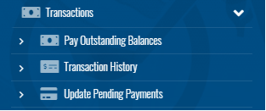

Your Registration ID is listed here under this season’s block (ex. C16A1F9F):
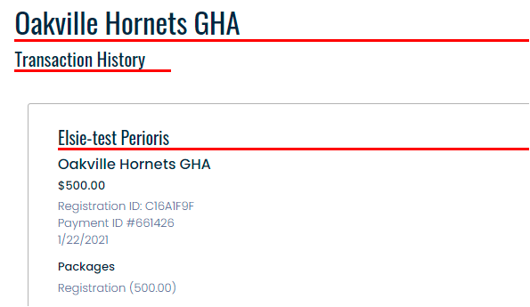

If you have any questions, please email Elsie at info@oakvillehornet.com. A reminder to check back on our website for any updates or changes to the schedule.

